CSE 3002 - INTERNET AND WEB PROGRAMMING LAB
DATE: 19_Dec_18
L – 43,44
FACULTY: PROF. SANDHYA P
DHRUBANKA DUTTA – 17BCE1019

A) Suppose you are working on a recipe website. Recipes have a title, a list of ingredients, and an instructions section. Make a web page that shows the recipe for grilled cheese sandwiches with bacon and tomato. The ingredients should be displayed as an unordered list, with no bullets. Meat ingredients should have a light red background color, vegetables should have a light-green background, and dairy products should have a light yellow. The title should be in a sans serif font of your choice, and the instructions should have a heading “Instructions” and the font for the instructions should be italic.
parta.css:
#title
{ font: sans-serif;
}
#meat {
background-color:#ff0000;
}
#veg {
background-color:#00ff00;
}
#dairy {
background-color: #ffff00 ;
}
#inc {
font: sans-serif;
font-style: italic;
}
#ul {
list-style-type: none;
}

Parta.html:
<!DOCTYPE html>
<html>
<head>
<link rel="stylesheet" type="text/css" href="parta.css">
</head>
<body>
<h1 id="title">GRILLED CHEESE SNADWICH WITH BACON AND TOMATO</h1>
<h3>INGREDIENTS</h3>
<ul style="list-style-type:none">
<li id="meat">Bacon</li>
<li id="veg">Tomato</li>
<li id="dairy">Cheese</li>
<li>Bread</li>
</ul>
<h3 id="inc">INSTRUCTIONS</h3>
<ol style="1">
<li>Spread about 1 tablespoon cheese into the bottom of a large skillet (or just leave some fat in the pan from the bacon).</li>
<li>Spread 1 tablespoon (can use more) onto one side of each slice of bread.</li>
<li>Place the 4 slices of bread butter-side down onto a large skillet or flat grill.</li>
<li>Top with 1 slice of cheese, 2 slices of tomato and 2 slices cooked bacon, then 1 more slice of cheese.</li>
<li>Cover with a slice of bread (butter-side facing outside).</li>
<li>Fry over medium turning once with a spatula until golden brown on both sides.</li>
</body>
</html>

B) Create a webpage that has two columns. Each column should use half of the width of the page. The left half should have a light-gray background and the right half should have a light-green background. The left half should have a list of the five best-selling books in Amazon’s kindle store, and the right should have a list of your five favorite celebrities or athletes.
Bleft.html:
<!DOCTYPE html>
<html>
<head>
<style>
body{
background-color:#808080;
}
</style>
</head>
<body>
<h1 align="center">5 BEST BOOKS ON AMAZON'S KINDLE STORE</h1>
<ol style=1>
<li>The Chase : Elle Kennedy</li>
<li>In The Light of The Garden : Heather Burch</li>
<li>A Very English Scandal : John Preston</li>
<li>Not So Nice Guy : R.S. Grey</li>
<li>Crazy Rich Asians : Kevin Kwan</li>
</ol>
</body>
<html>

Bright.html:
<!DOCTYPE html>
<html>
<head>
<style>
body{
background-color:#61e400;
}
</style>
</head>
<body>
<h1 align="center">5 ATHLETES</h1>
<ul style="disc">
<li>Cristiano Ronaldo</li>
<li>LeBron James</li>
<li>Tiger Woods</li>
<li>Sebastian Vettel</li>
<li>Rafael Nadal</li>
</ul>
</body>
</html>
partb.html:
<!DOCTYPE html>
<html>
<frameset cols="*,*">
<frame src="bleft.html">
<frame src="bright.html">
</frameset>
</html>

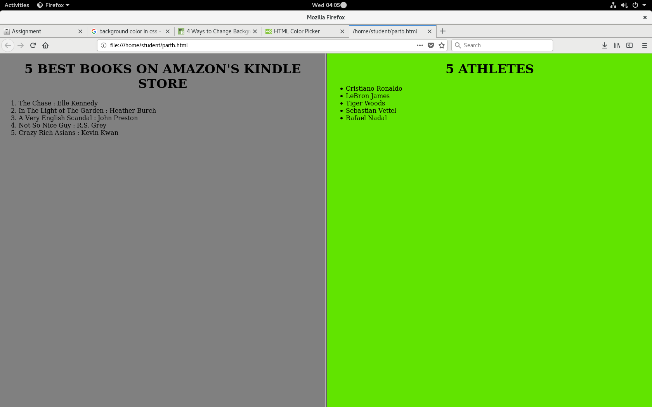

C) Construct a HTML Code for the following Table.

this cell spans across three columns
Hello | good | Bye
Lorem | Ipsum | Dolor
this cell spans across two columns |  | !!!

Apply External CSS for the following.
- Apply spacing for border
- Give a Caption for the table
- Font Face should be Arial of size 12
- Set different colors for rows 1, 2 and 3.
- Repeat same color as row 1 in row 4.
When more contents are typed in a cell, the size of the font should be decreased automatically.

Table.css:
#table1 {
border-collapse: separate;
border-spacing: 15px;
font-size-adjust: 0.58
}

th, td {
padding: 15px;
text-align: left;
}

#tr1
{background-color:#FFFF00 ;}

#tr2
{background-color:#008080;}

#tr3
{background-color:#FF00FF;}

partc.html:
<!DOCTYPE HTML>
<html>
<head>
<link rel="stylesheet" href="table.css">
<title>
PART C LAB 3
</title>
</head>
<body>
<table id="table1">
<tr id="tr1">
<td colspan="3">this cell spans accross three columns</td>
</tr>
<tr id="tr2">
<td>Hello</td>
<td>good</td>
<td>bye</td>
</tr>
<tr id="tr3">
<td>Lorem</td>
<td>Ipsum</td>
<td>Dolor</td>
</tr>
<tr id="tr1">
<td colspan="2">this cell spans across two columns</td>
<td>!!!</td>
</tr>

